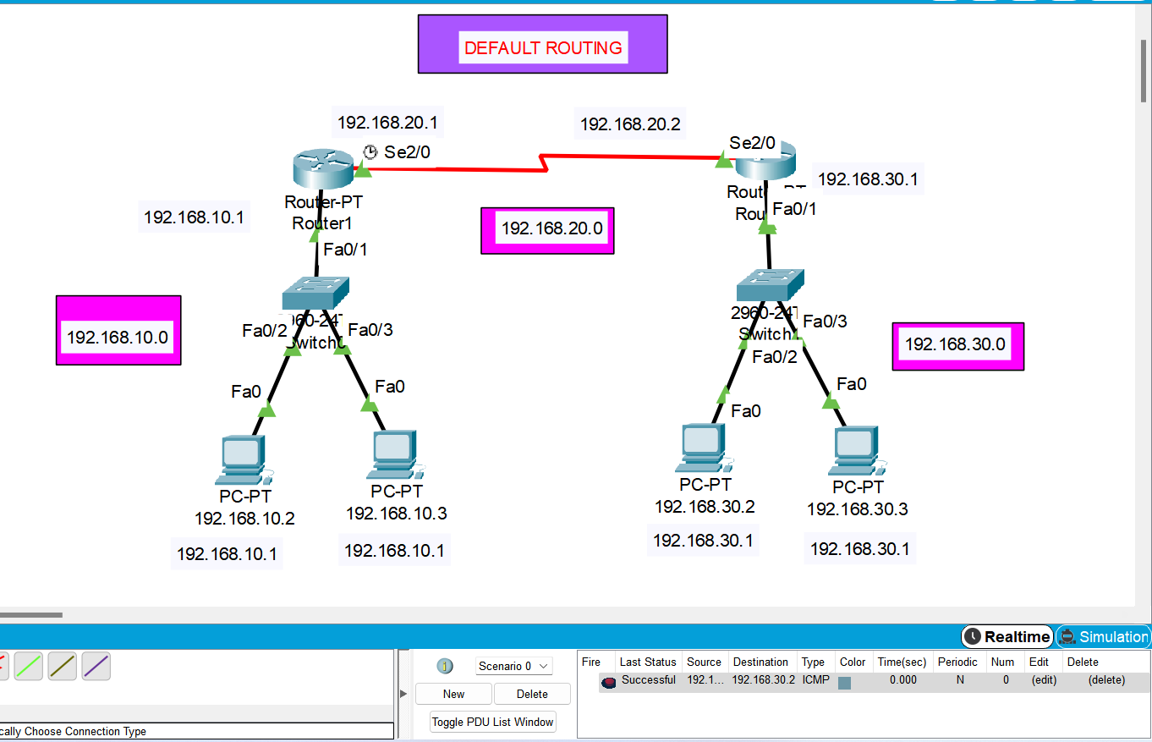

**ROUTER R0**

Router> enable

Router# config t

Enter configuration commands, one per line. End with CNTL/Z.

Router(config)#ip route 0.0.0.0 0.0.0.0 192.168.20.2

Router(config)#exit

Router#

%SYS-5-CONFIG_I: Configured from console by console

Router# copy running-config startup-config

Destination filename [startup-config]?

Building configuration...

[OK]

**ROUTER R1**

Router> enable

Router# config t

Enter configuration commands, one per line. End with CNTL/Z.

Router(config)# ip route 0.0.0.0 0.0.0.0 192.168.20.1

Router(config)#exit

Router#

%SYS-5-CONFIG_I: Configured from console by console

Router# copy running-config startup-config

Destination filename [startup-config]?

Building configuration...

[OK]